Full Name: Rakyan Satrya Adhikara

Student ID: 219548135

Assignment 1

1. ThinkQnsWeek1
   1. The smallest computer I have ever seen is Sony Smartwatch 3
   2. An ‘algorithm’ is a process to be followed in problem-solving operations, especially by a computer.
   3. Computer science is more theoretical. While, computer programming is more practical.
   4. Aspects of computational thinking:
      1. Decomposition
         * Getting to know how to make each sushi
      2. Pattern Recognition
         * The similarity between those is that it’s all about making a sushi
      3. Generalisation and Abstraction
         * Making a wrap is similar to making a sushi
      4. Algorithm Design
         * Make an algorithm for making a sandwich that is similar to making a wrap
2. ThinkQnsWeek2
   1. Digital: A set of information that is being expressed as series of 1 and 0
   2. It’s because a logic 1 and 0 is quick to recognize, can be sent over long distance with high precision.
   3. The CPU is the one that is attached to the motherboard (square, metallic), the memory is the one that is also attached to the motherboard (consists of many capacitors), and the hard drive is one the upper right, above the fan.
   4. The starting step is the **fetch.**
   5. This algorithm converts a number of base 10 into a different base
3. ThinkQnsWeek3
   1. There are many operating systems, such as Windows, iOS, Macintosh, Android, Linux, MacOS, Ubuntu, CentOS, Fedora, Chrome OS. Computer need Operating System because to enable the user to design any application without concerning the detail of computer internal structure.
   2. Meaning that a computer can run more than one task at the same time. It is necessary because it allows more efficient use of the computer hardware.
   3. File system is a software that manages data on hard drives.
   4. Python outputs:
      1. First one, will print letter a, b and c, and ‘count is 3’. All of them on different lines.
      2. Second one will print a, b and c, and at the end, will print ‘count is 3’, all in different lines.
      3. Third one:
         * It will print ‘byeeeeeee’, create a new line and print ‘hello’
         * It will print ‘hello’ first, and then the rest of letter ‘e’
         * It will print “hello ‘world’”, since the backslash makes the quotation marks printable
4. ThinkQnsWeek4
   1. It is important because it is more efficient to make applications (i.e. Mobile Applications, Web Applications)
   2. It needs to be interpreted or compiled since machine won’t understand high-level language, such as python.
   3. Syntax and Semantics
      1. Syntax of a programming language: An expression is a valid program in each programming language if it conforms to the rules of the programming language
      2. Semantics of a programming language can be given by what it computes
   4. Interpretation and Compilation
      1. Interpretation runs the code without compiling them into machine code
      2. Compilation runs the code by translate them into machine code and run it by the machine
   5. There are Integers, Strings, Booleans, and Floats
   6. Dynamic typing languages are those language that does not require explicit declaration of the variables.
5. ThinkQnsWeek5
   1. Equations
      1. Einstein’s Field Equation
      2. Rossomo’s formula
   2. List operations
      1. *len([1,5,7,3,9])* = 5
      2. *listC = [1,2,3] + [4,5,6]* 🡪 *[1,2,3,4,5,6]*
      3. *[hi]*4*
      4. *3 in [1,2,3]*
      5. *list.count(‘a’)*
      6. *list(filter(lambda a: a != 2, [‘a’,’b’,’f’,’a’,’e’,’a’,’a’]))*
      7. *list.insert(‘a’,1)*
      8. (if the list is x) *x.sort()*
      9. max([1,3,5,7,9])
   3. 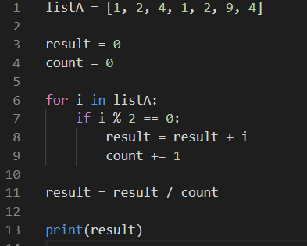
6. ThinkQnsWeek6
   1. Check how to sort the name (by alphabetical order or length order)
   2. 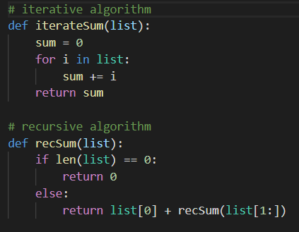
   3. 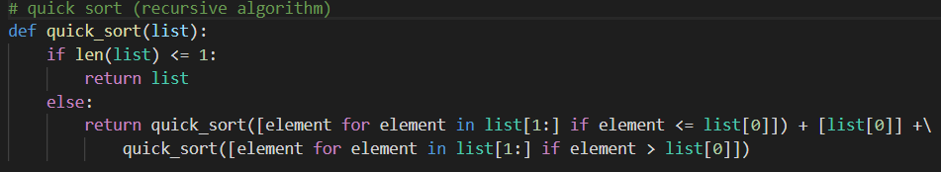
   4. To create an order-K Sierpinski Triangle, you draw three Sierpinski Triangles of order K-1, each of which has half the edge length of the larger order-K triangle you want to draw. Those three triangles are positioned in what would be the corners of the larger triangle; together they combine to form the larger triangle itself.
7. ThinkQnsWeek7
   1. **Insertion sort** does N - 1 **comparisons,** while **Merge sort** does N comparisons
   2. Meaning that the complexity of the function have excellent algorithm.
   3. InsertionSort requires 1 variable of the same type being sorted.While, MergeSort requires n/2 of the same.
   4. Meaning how complex the algorithm is
   5. NP is problems whose solutions are hard to come by but can be verified in polynomial time make up the complexity class
   6. Example if NP is sudoku
   7. Yes, P=NP
   8. BFT & DFT
      1. BFT:
         * A 🡪 B
         * A 🡪 C
         * B 🡪 D
         * C 🡪 E
         * C 🡪 F
         * C 🡪 G
      2. DFT
         * A 🡪 B 🡪 D
         * 🡪 C 🡪 E
         * 🡪 F
         * 🡪 G
   9. Advantages:
      1. BFT:
         * Solution will definitely be found out by BFS If there are some solution.
         * If there are more than one solution then it will find solution with minimal steps.
      2. DFT:
         * Finding Shortest Path.
8. ThinkQnsWeek8
   1. Like recursive problem solving, break a problem down to smaller problems, solve the smaller problems and then combine the solutions to get a solution to the original problem
9. ThinkQnsWeek9
   1. An **Internet Standard** ensures that hardware and software produced by different vendors can work together.
   2. Indexes:
      1. “Computing”: D1, D2
      2. “Algorithms” and “love”: D1, D2
   3. The **random surfer** model provides a basis for calculating the **Page Rank algorithm**.
10. ThinkQnsWeek10
    1. In cryptography, a cipher is an algorithm for encryption and decryption
    2. DES use XOR operation
    3. AES use XOR two 128-bit strings operation
    4. Public key to encrypt, private key to decrypt. Therefore, it needs to be different.
    5. Cryptocurrency is an electronical token that can be used to exchange for goods and services.
    6. Block chain is part of cryptography, that is being used for cryptocurrency.